**Assisted Practice: 3.13 Empty an S3 Bucket**

This section will guide you to:

* Empty an S3 bucket

This lab has three subsections, namely:

3.13.1 Selecting the S3 bucket you want to empty

3.13.2 Emptying the bucket

3.13.3 Pushing the files to GitHub repositories

**Step 3.13.1:** Selecting the S3 bucket you want to empty

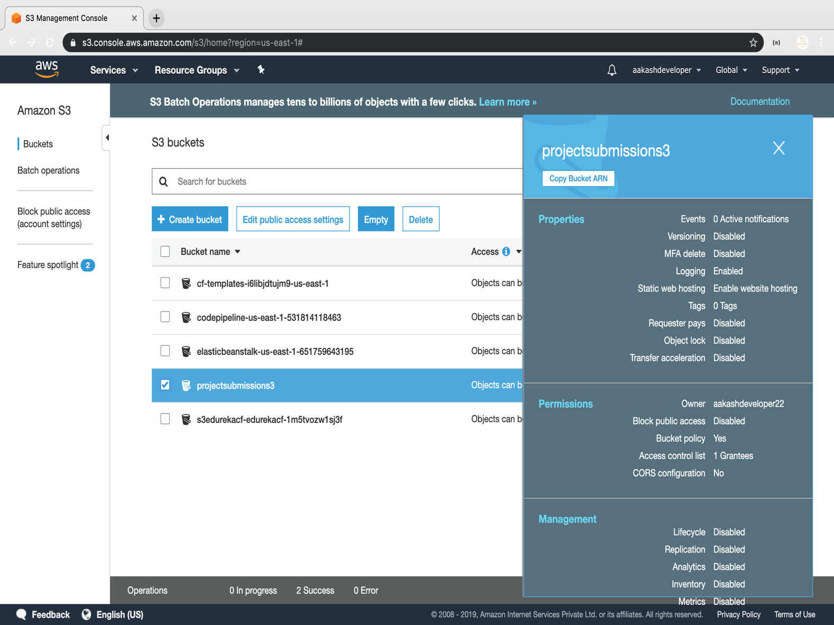

**Step 3.13.2:** Emptying the bucket

* Verify the content present in the bucket

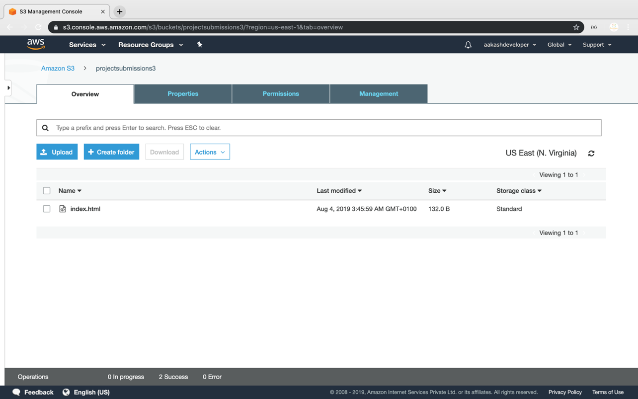

* Empty the bucket

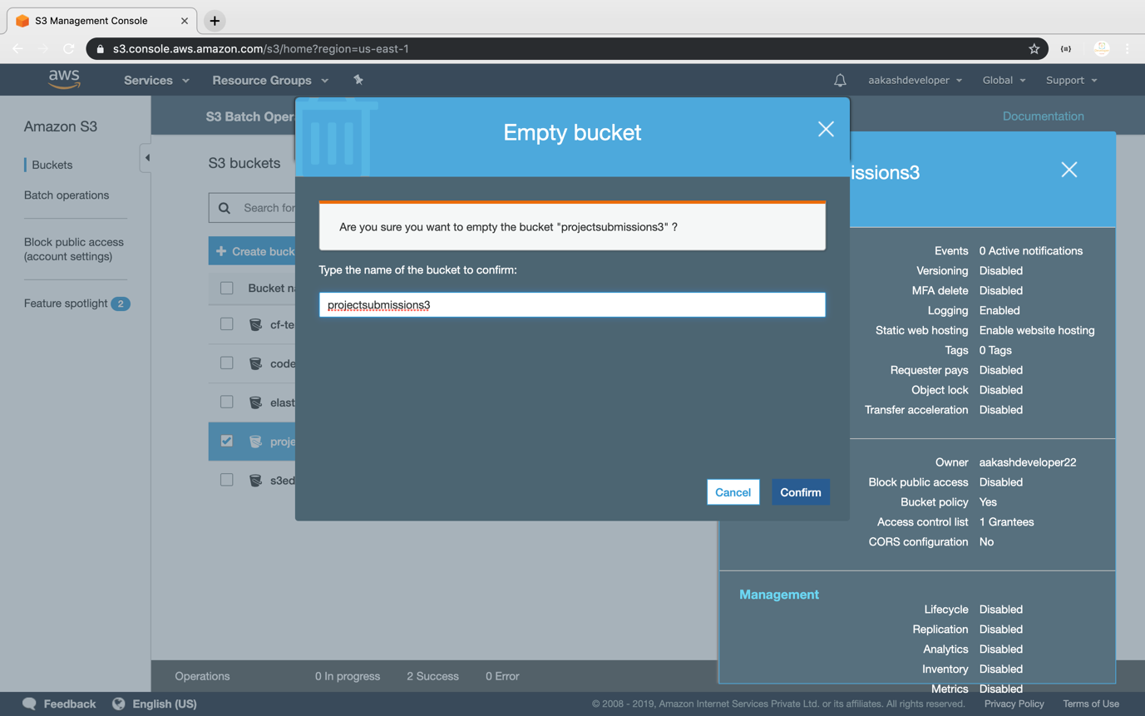

**Step 3.13.3:** Pushing the code to your GitHub repositories

* Open your command prompt and navigate to the folder where you have created your files.

**cd <folder path>**

* Initialize your repository using the following command:

**git init**

* Add all the files to your git repository using the following command:

**git add .**

* Commit the changes using the following command:

**git commit . -m “Changes have been committed.”**

* Push the files to the folder you initially created using the following command:

**git push -u origin master**